## Merchant

Demo date: Oct 9, 2024  
Scoping start date: Oct 9, 2024

MSA Signature Date: Dec 24, 2024  
Onboarding Kick Off Date: Jan 6, 2025

[If Exists] Opt Out Date: NA  
Go Live Date: Jan 20, 2025

GTM POC: Sean  
Implementation POC: Jeff

ERP: QBO

Tax Integration: No Tax

### 

### Key people at Merchant

| [Alex Teller](https://www.linkedin.com/sales/lead/ACwAABMOVqYBLHw6ZzSxz6bfHIH9RPN17nMvNUo,NAME_SEARCH,g0VP?_ntb=uECg8G7YQbOusZlqn0suMQ%3D%3D) | President |
| --- | --- |
| Mike Angwin | Head of Fin? |
| [Taylor Feldt-Hjelvik](https://www.linkedin.com/in/taylor-feldt-hjelvik-6b5610163/) | Accountant |

### 

### 

| Notes Sections [Ops International Team to Ignore] *(AE/ Implementation to fill)*   * Info on how merchant bills - Bills out of QB and HS, come contracts have complex parent child relationships, hardware/software      * Is there any important merchant relationship information?  1) What is the merchant temperament? - Temperament is great, feels like a friends and family partner thats been evaluating us since pre seed * 2) Is there a key POC: (i.e.: who is the buyer/decision maker?) - Alex Teller 3) What are the Tabs features that the key POC cares about? - Ability to manage bespoke contracts |
| --- |

### 

Company summary  
*(AE to fill)*

StrongArm sells Hardware/Software based around safety in warehouses

Goals (North star)  
*(AE/ Implementation to fill)*

What is the merchant's goal? What pain are we solving? Why are they buying Tabs?

Is there an opt out clause? If so, what is the merchant looking for so they do not exercise it?

no

### Billing model *(AE/ Implementation to fill)*

* Are there unique things about the customer creation process for this merchant? - no
* Information on how merchant bills - changes depending on the customer - very bespoke
* How contract is broken up -NA
* One off things to know about the merchant NA

### Contract Processing Steps *(Implementation/Success to fill)*

1. Steps to process
   1. Customer creation - all customers exist in QBO and should *not* need to be created in Tabs - if you cannot find customer in QBO go ahead and create in Garage
      1. Customer name can be found in “Client” (first row in Order Form)
   2. Start date for invoicing and revenue is “Order Form Effective Date”
   3. Term length found in “Order Form Term”
   4. Item Name comes from left-most column in order-form
      1. i.e. “Access” or “Expenses”
   5. Amount comes from right-most column in order form

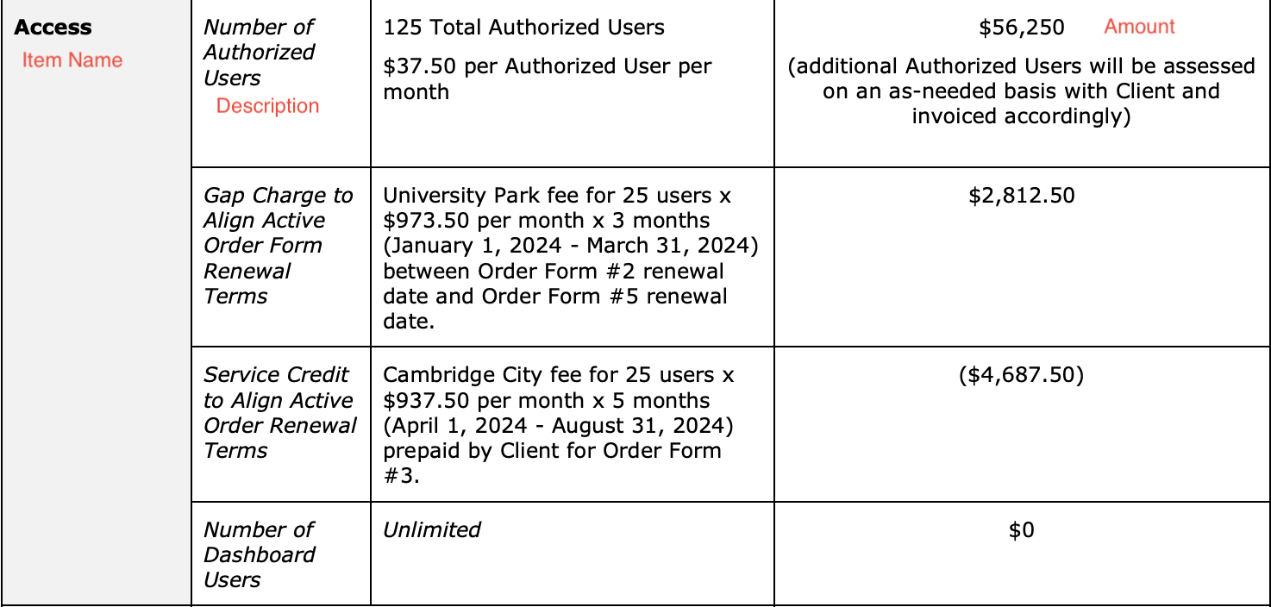

1. Anything to ignore in contracts?
   1. Billing terms where Fee is “WAIVED” “INCLUDED” or N/A
2. Specifics processing things the merchant has requested that may differ by contract (e.g. always back-date invoice date to final day of the month)
3. Default Service Term
   1. Stated in “Order Form Term”
4. Default Net Payment Terms
   1. 30
5. Default Billing Frequency
   1. Use Section 3. Payment Terms to find specifics payment schedule
6. How do we handle taxes as a line item?
   1. N/A

### Events Processing (if necessary) *(Implementation/Success to fill)*

* Any important information on events billing
  + N/A

Integration Items Processing (if necessary)  
*(Implementation/Success to fill)*

* What are the instructions for assigning integration items?
  + Waiting on customer to fill these out - will update [Ashni Walia](mailto:awalia@tabsplatform.com)when available

Post Processing Communications (if necessary)  
*(Implementation/Success to fill)*

* Does the Ops Team need to notify anyone on the team re: completion of processing batches in Implementation or Active phase?
* Who needs to be notified and when?
  + Example:
    - Who: Customer Success [Azmat Aziz] needs to be notified
    - Where: Messari internal merchant channel
    - When: contracts are processed [Merchant Phase: Active]

### Customer Information *(Implementation/Success to fill)*

* Any important information on specifics customers of this merchant
  + Special memo’s certain invoices require
  + Invoice changes due to merchant/customer relationship

### Feature Requests *(AE/Implementation/Success to fill)*

* FR 1
  + What is it
  + Why it's important
  + Urgency

NA

### Rewatch Calls *(AE/Implementation/Success to fill)*

* They are in the Slack Channel